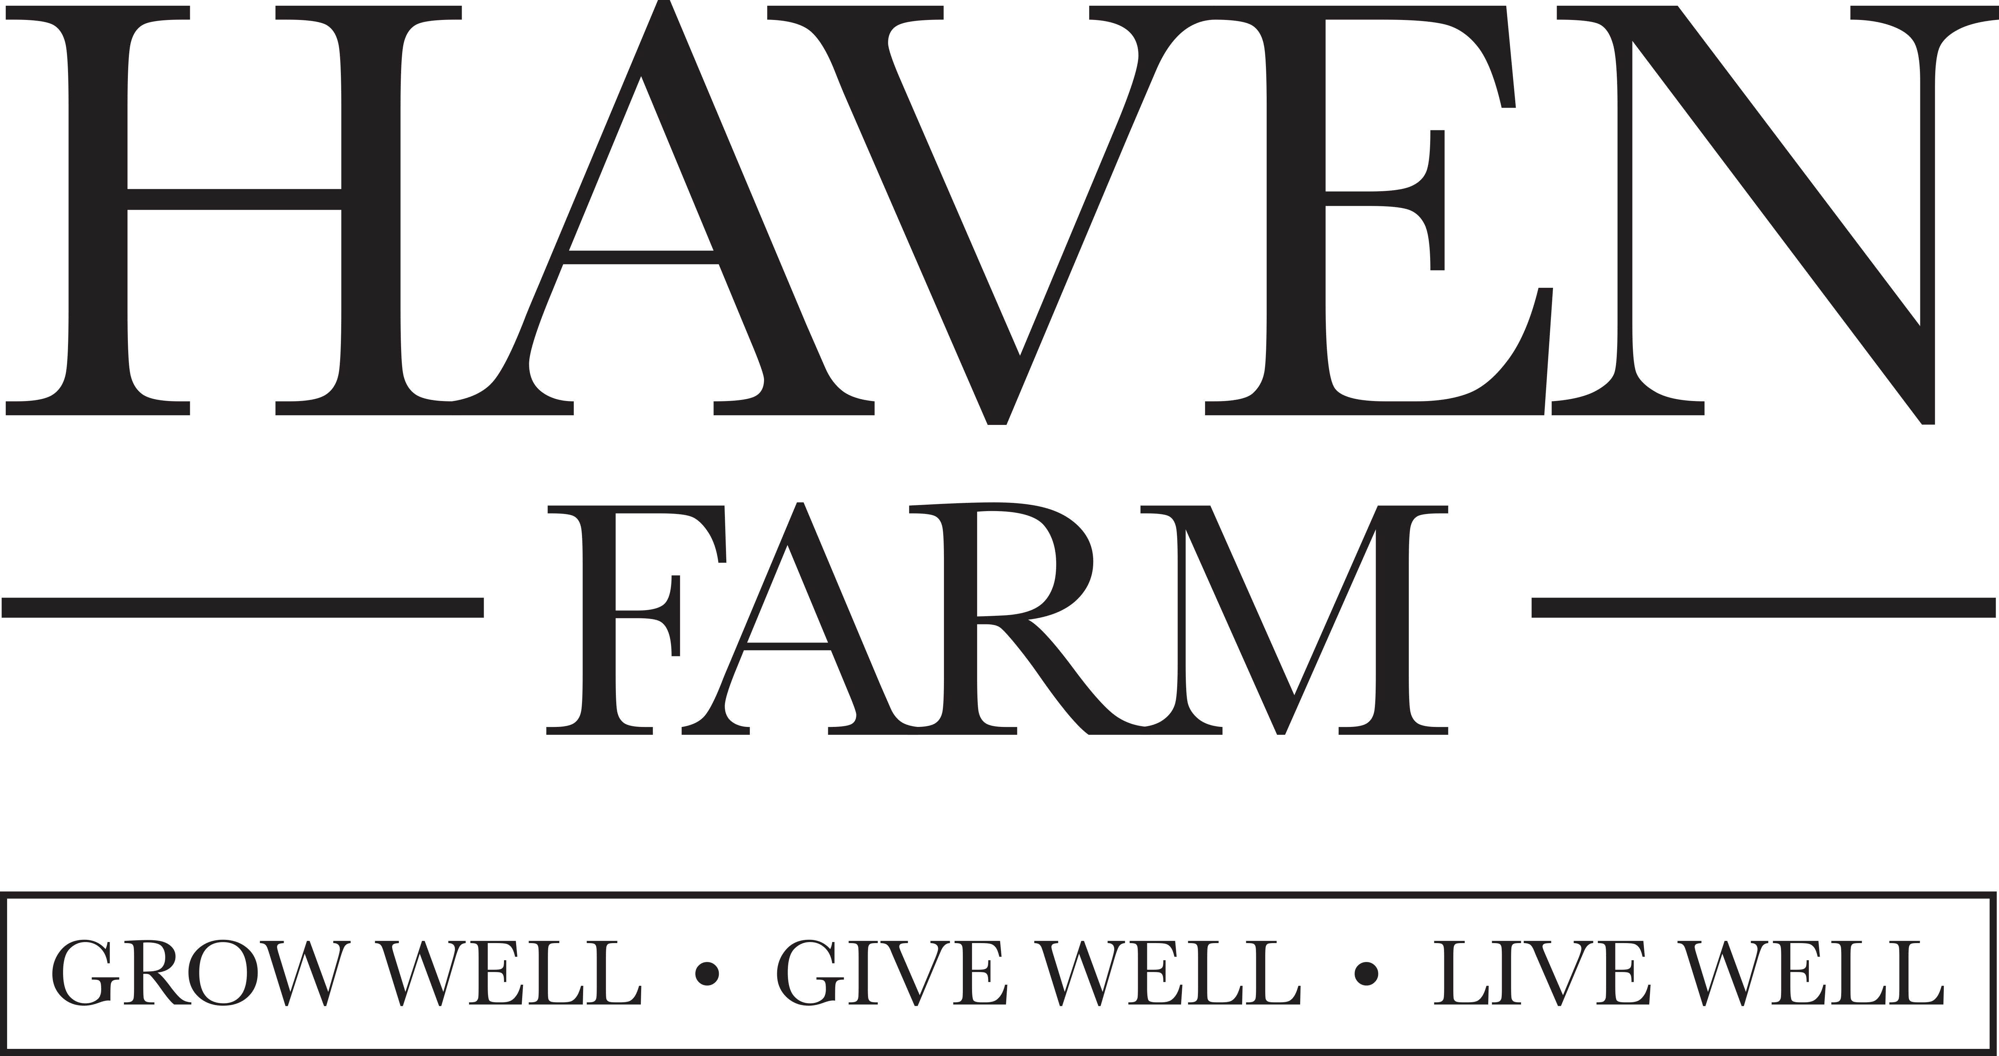

FARM & EVENTS OPERATIONS CREW

SUMMARY: Haven Farm is seeking an enthusiastic people lover to assist with set up, break down, parking, and other projects at our farm and event venue. Operations crew will assist with venue set up, assist guests with parking, and perform other various duties to provide an excellent experience for each event. Team members should provide professional, friendly service to guests, and work in harmony with other team members.
Nature of the position: Hourly; weekend & evening work required. Must be at least 18 years old. Essential Duties: Prep and clean event venues and equipment as specified by Events Manager. Grounds keeping and general farm labor. Handling and serving alcoholic beverages. Equipment operator, agricultural, or landscaping experience is preferred.

Duties include but are not limited to:
- General Grounds keeping as assigned.
- General Farm labor as assigned.
- Setting up spaces on the property, including ceremony chairs, and reception tables and chairs
- Moving furniture (arbor, pews, etc.) from one location to another
- Cleaning and storing furniture (arbor, pews, etc.)
- Cleaning and re-stocking restrooms (before, during, and after event)
- Picking up trash as needed
- Taking trash from various receptacles to dumpster, breaking down boxes
- Cleaning wagons for tractor and wagon rides
- Grounds keeping near venues, as directed (blowing leaves, tidying pine straw, maintenance weeding, gardening, etc.)
- Golf carts- charged and cleaned before every event; park and charge after each event
- Stock toilet paper, cleaning supplies, lighter fluid, paper towels, etc. Maintain the inventory and inform supervisor when more supplies are needed.
- Start fire, stock firewood at fire pit, maintain fire and extinguish completely
- Assist with parking for events
- Ensure farm gates, doors, and facilities are locked and secure, lights out & alarms set

Physical Demands:

While performing the duties of this job, the employee is regularly required to use hands to fingers, handle or feel, reach with hands and arms and talk or hear. The employee is frequently required to stand, walk, sit, climb or balance. The employee is occasionally required to stoop, kneel, crouch, crawl and smell. The employee must regularly lift and/or move up to 50 pounds and occasionally lift and/or move up to 100 pounds with assistance. Specific vision abilities required by this job include close vision, distance vision, peripheral vision, depth perception and ability to adjust focus.

Work Environment:

While performing the duties of this job, the employee is regularly exposed to outside weather conditions. The noise level in the work environment is usually moderate.

REQUIRED EXPERIENCE:
- Able to lift and carry 50- 100 lbs.
- Must be available evenings & weekends.
- Punctuality and reliability
- Event or Restaurant experience a plus

Hours will vary with seasons and weather. Please be prepared to stay as late as necessary to finish the job. Potential for additional hours at our shoppe. Candidates must be able to thrive in a fast-paced sales environment and work well under pressure.

